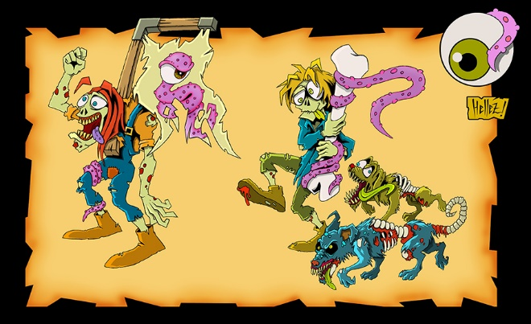
“THE EXPERIMENT”
“Can a group of high school students create a fun, professional, playable game together?” “Who will show their leadership ability? Who will waste time?” Who will get an A?” “Who will be the MVP?” “Could this game become popular and played other than just in West High School?” “How?”
Game Requirements-
-Multi-Level 3D Game
-Characters (Good and Bad) with a Story (2D and 3D Designs)
-A minimum of 10 sounds used in the game
-Some sort of online presence (website? Social media?)
-3D Designs/Models created and used in the game
-Animation at the start of the game
-A start button to begin the game
-A clear way to win or lose
-A Score counter

